Physics 30 Lessons 1 to 6 Doomsday Test D

Name ________________
____/ 27 (mc/nr) + ____/ 9 (er) = ____ /36 Period ______

Use the following information to answer the next question.

2.4 kg
9.5 kg
3.2 m/s
8.4 m/s

The two objects shown above collide head-on. The velocity of the 9.5 kg object after collision is 5.4 m/s to the left.

- The velocity of the 2.4 kg object after collision is
A. 15 m/s to the right
B. 8.7 m/s to the left
C. 8.0 m/s to the right
D. 6.2 m/s to the left
_________________________________

- Two carts, each with a spring bumper, collide head-on. At one point during the collision, both carts are at rest for an instant. At that instant, the kinetic energy that the carts originally possessed is almost completely
A. lost to friction
B. transformed into heat and sound
C. converted into kinetic energy in the spring bumpers
D. converted into potential energy in the spring bumpers

Numerical Response

- A 1 575 kg car, initially travelling at 10.0 m/s, collides with a stationary 2 250 kg car. The bumpers of the two cars become locked together. The speed of the combined cars immediately after impact is __________m/s.

(Record your three-digit answer in the numerical-response section on the answer sheet.)

- A 115 g arrow travelling east at 20 m/s imbeds itself in a 57 g tennis ball moving north at 42 m/s. The direction of the ball-and-arrow combination after impact is
A. 46º N of E
B. 46º E of N
C. 25º E of N
D. 25º N of E

- In an inelastic collision, the energy that appears to be missing is converted into
A. sound and momentum
B. force and momentum
C. sound and heat
D. heat and force

Use the following information to answer the next question.

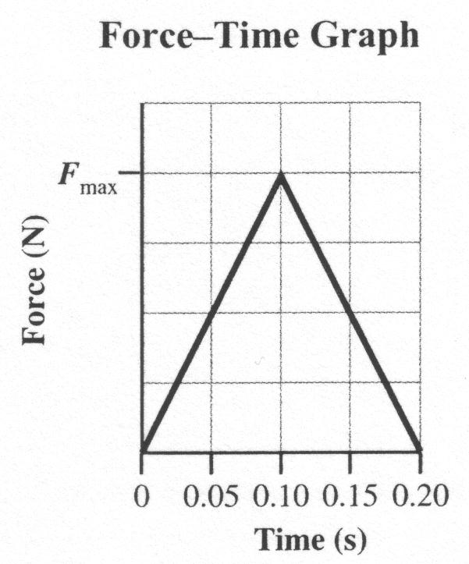

This graph shows the relationship between the force on a 0.801 kg football and the time a kicker’s foot is in contact with the ball. As a result of the kick, the football, which was initially at rest, has a final speed of 28.5 m/s.
Numerical Response

Numerical Response

- The magnitude of the maximum force, Fmax, exerted on the ball during the kicking process, expressed in scientific notation, is a.b × 10^{c} N. The values of a, b, and c are _____ , _____ , and _____.

(Record all three digits of your answer in the numerical-response section on the answer sheet.)

- Which of the following units are correct units for momentum?
A. J•s
B. N•m
C. N•s
D. N/J

Use the following information to answer the next four questions.

The distribution of energy released during the burning of gasoline in a car is illustrated below.
Energy Wasted as Heat Energy Delivered to the
from Engine Parts Car’s Drive Train

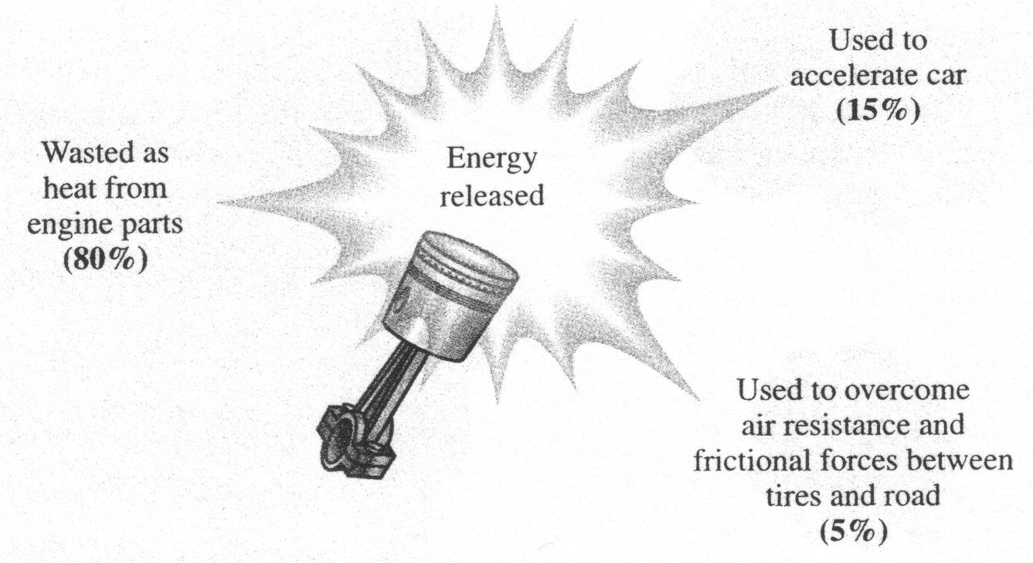
Gasoline releases 30.2 MJ/L during burning. A particular car has a mass of 1.60 × 10³ kg. In a test drive, the car accelerated from 3.00 m/s to 15.0 m/s over a distance of 115 m.

- The maximum amount of energy that would be delivered to the drive train when 65.0 L of gasoline is burned is
A. 1.51 × 10² MJ
B. 3.93 × 10² MJ
C. 1.96 × 10³ MJ
D. 9.82 × 10³ MJ

- The change in the kinetic energy of the car during the test drive is
A. 9.60 × 10³ J
B. 1.15 × 10⁵ J
C. 1.73 × 10⁵ J
D. 1.80 × 10⁵ J

- The magnitude of the impulse on the car during the test drive is
A. 4.80 × 10³ kg•m/s
B. 1.92 × 10⁴ kg•m/s
C. 2.40 × 10⁴ kg•m/s
D. 2.88 × 10⁴ kg•m/s

Use your recorded answer from Multiple Choice 8 to answer Numerical Response 3.*
Numerical Response

Numerical Response

- The average net force on the car during the test drive, expressed in scientific notation, is a.bc × 10^{d} N. The values of a, b, c, and d are ____, ____, ____, and ____.

(Record all four digits of your answer in the numerical-response section on the answer sheet.)
*You can receive marks for this question even if the previous question was answered incorrectly.
Use the following information to answer the next three questions.

90 m Ski Jump

An elevation profile of the 90 m ski jump at Canada Olympic Park in Calgary is shown below. The skiers slide down a 111 m long ramp before taking off at the “table point.” The distance from the table point to the “norm point” (the beginning of the steepest section of the landing hill) is 90 m, hence the name of the jump. Farther downhill, at the end of a straight section of 24.0 m, is the “critical point.” If skiers fly past the critical point, it becomes dangerous to land because the landing hill starts to flatten out.

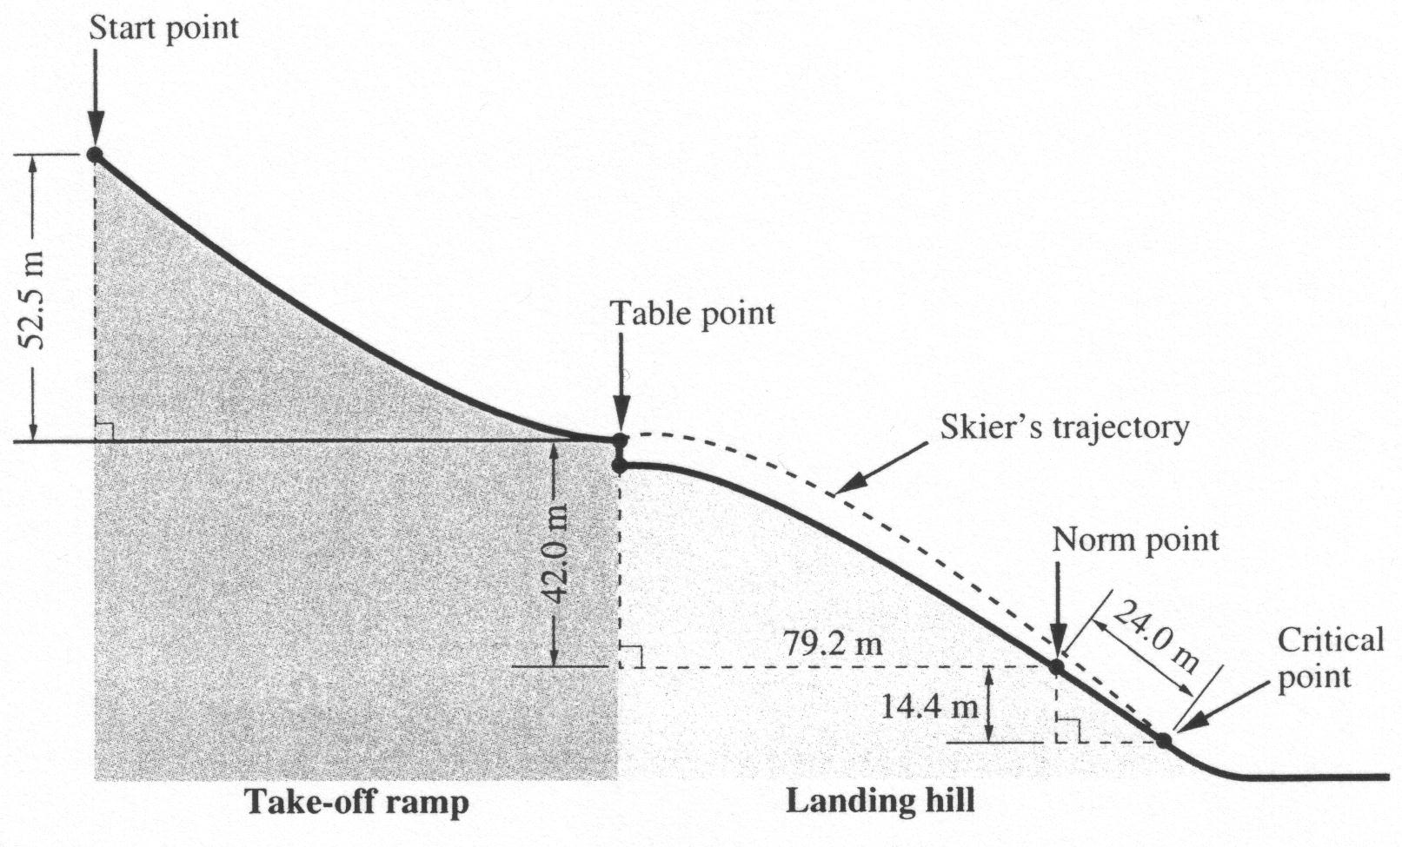

During a ski jumping competition, a skier’s speed at the table point was
95 km/h, and she landed at the critical point with a speed of 85 km/h. The
combined mass of the skier and her equipment was 60 kg.

- The change in the skier’s gravitational potential energy as she moved from the table point to the critical point was
A. –2.5 × 10⁴ J
B. –3.3 × 10⁴ J
C. –3.6 × 10⁴ J
D. –6.7 × 10⁴ J

- Current ski jumping techniques actually slow down the ski jumpers on the way to the bottom of the hill. The skier’s speed upon landing at the critical point was 85 km/h. What was the change in this skier’s kinetic energy on her flight from the table point to the critical point?
A. –8.4 × 10¹ J
B. –3.0 × 10² J
C. –4.2 × 10³ J
D. –5.4 × 10⁴ J

- The reduction in flight speed as a skier moves through the air is mainly due to the aerodynamic lift generated on the skier in “sailing position.” The work done by this force acts to reduce the
A. kinetic energy of the skier
B. potential energy of the skier
C. time spent in the air by the skier
D. horizontal distance travelled by the skier

_________________________________-

Use the following information to answer the next question.

Two identical metal pucks were made to collide on a frictionless surface. Before the collision, puck 1 was moving at 6.00 m/s and puck 2 was stationary. After the collision, the pucks moved as shown in the diagram below.
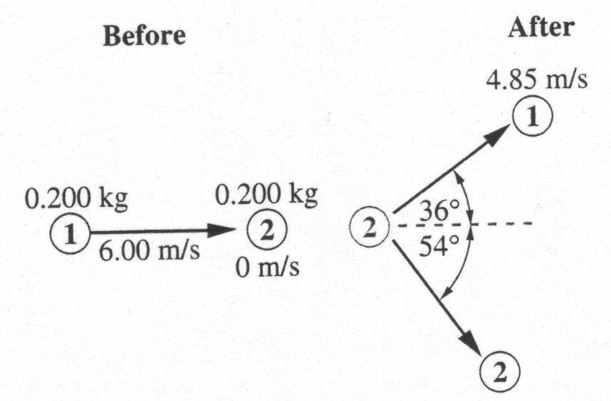

- The magnitude of the momentum of puck 2 after the collision was
A. 1.33 kg•m/s
B. 0.970 kg•m/s
C. 0.705 kg•m/s
D. 0.570 kg•m/s

